Presentation and use of the new function “hvcheckstruct”

Role of the new function “hvparameters”

Function “hvcheckstruct” was created in order to test variables used within HVLab which have structures format. The function checks that these variables have the correct format according to their use and definition inside HVLab.

Structures inside HVLab

Definition of a structure

Structures are multidimensional MATLAB arrays with elements accessed by textual field designators and based on the notation of a comma-separated list. The fields of a structure can contain any kind of data. For example, one field might contain a text string representing a name, another might contain a scalar representing a billing amount, a third might hold a matrix of medical test results, as seen on figure 1:

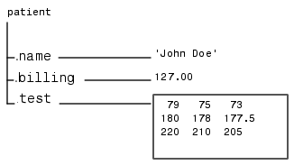

Figure 1: Example of structure with different types of data inside the fields

The most common way to access the data in a structure is by specifying the name of the field that you want to reference. With the example of figure 1, “patient” is a structure, then “patient.name” will be a variable associated with the structure “patient” under the field called “name”. This variable will then be accessible by typing “patient.name” under MATLAB.

Type of structure present in HVLab

MATLAB version of HVLab uses and creates different types of structures. For the moment, two types of structures are actually tested with “hvcheckstruct”, but the function will be upgraded as HVLab will use new types of structures. The two types of structure are defined as follow:

TYPE 1: Global parameter structure

This first type corresponds to the global parameter structure, as defined in the function “hvparameters”, with the following fields (here HV is the name of the structure):

Parameter name | Description
HV.INCHANNELS | number of data channels to be acquired
HV.FIRSTCHANNEL | number of the first acquisition channel
HV.INCHANNEL(16).DESCRIPTION | array of strings describing data in each channel
HV.INCHANNEL(16).VOLTAGE | maximum voltage of the input signal
HV.INCHANNEL(16).UNIT | array of strings containing units of each channel
HV.INCHANNEL(16).RANGE | maximum range of input signal
HV.OUTCHANNELS | number of DtoA channels to be output
HV.OUTCHANNEL(2).RANGE | maximum range of output signal
HV.OUTCHANNEL(2).UNIT | array of strings containing units of each channel
HV.DURATION | duration of input time history (s)
HV.HIGHPASS | lower frequency limit (Hz) - if supported by hardware
HV.LOWPASS | upper frequency limit (Hz)
HV.UNIT | data units as string variables
HV.TINCREMENT | sampling increment of time history (s)
HV.FINCREMENT | frequency increment of spectrum (Hz)
HV.AMPLITUDE | peak amplitude of function
HV.OFFSET | offset applied to function
HV.WINDOW | spectral window
HV.FILTERPOLES | number of poles in filter
HV.MESSAGES | Enables reporting of statistical information
Table 1: Definition of fields in the global parameter structure

TYPE 2: Data structure

This second type corresponds to the general data structure. If “MYDATA” is a HVLab data structure, then the fields will be as follow:

MYDATA.dxvar
MYDATA.dtype
MYDATA.title
MYDATA.yunit
MYDATA.y2unit
MYDATA.xunit
MYDATA.stats
MYDATA.x
MYDATA.y

Limitations of “hvcheckstruct”

The function “hvcheckstruct” is used with the tested variable as input. The output of the function is a value which is 0 if the input variable has an incorrect format or 1 if the format is correct. Verification of the input data for the function “hvcheckstruct” will proceed as described in figure 2:

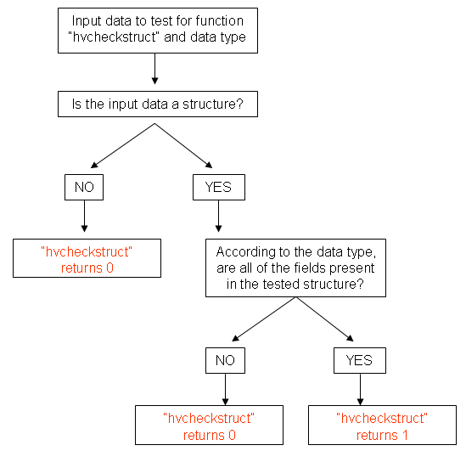
Figure 2: Algorithm of the function “hvcheckstruct”

The function “hvcheckstruct”, as shown in figure 2, will only test if all the fields required for the chosen data type are present in the input variable to test. “hvcheckstruct” will not test if the variables associated with each field of the structure have the correct format: for example, if a data structure is called “MYDATA” and contains all the required fields for a data structure under HVLab, then “hvcheckstruct” will return 1, even if “MYDATA.dtype” equals 0 or is a string.

